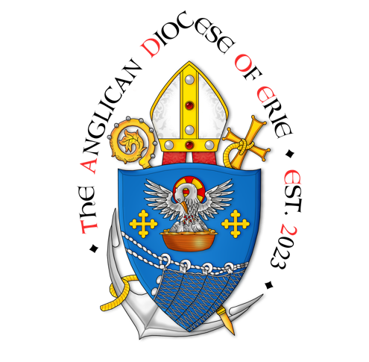

Pentecost

27 May 2023

Greetings, in the name of our Lord, Jesus Christ!

Today the church celebrates the feast of Pentecost, the day that the Holy Spirit, like a rush and mighty wind, blew into the upper room, filling all the apostles with the ability to speak in languages previously unknown to them, allowing them to go to the ends of the Earth preaching the gospel message and baptizing, in the name of the Father, and of the Son of the Holy Spirit.

In my office is an icon of the day of Pentecost. On this icon, you see the apostles seated in the upper room with a blessed mother seated at the center. I have always found the symbolism of this icon to be fascinating: all the apostles in a semi-circle in the blessed mother at their center with clothes of fire dancing above their heads. What’s fascinating about this is the fact that it is Mary who is at the center of the great apostles of the Church. Why is that? Tradition has it that Mary, along with the Holy Spirit, brings unity to the church.

I find it fitting that our diocese has undergone great change during the season of Easter and leading into Pentecost: a season of new birth, of new beginnings, and now into a season of launching. Since my ordination to the diaconate, my ministry has held a strong devotion to the blessed Virgin Mary. In my most trying times, it has been through my devotion to the Blessed mother that I have been able to seek comfort and solace in whatever it was that I was going through. Because of that, as your bishop elect, I am here by declaring this year, a year of devotion to Mary: the mother of the church, the mother of us all.

Throughout this year, we will be praying for the Blessed Mother's intercession to bring unity in our diocese, our communion, and all throughout the church. We will pray for her guidance and strength as we live out our call to live a life that is centered in the gospel, where our faith is anchored in Christ, with a desire of reaching the world and serving with compassion.
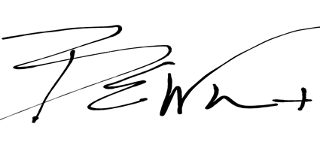
The Very Reverend Brent E. Whetstone
Bishop Elect
The Anglican Diocese of Erie

